Abdominal pain after colonoscopy/polypectomy
Stem: 55y male presenting to ED, You 4 hours earlier had done a colonoscopy and removed two adenomatous polyps, there were removed without difficulty and they were benign looking . Patient is now withleft lower quadrant abdominal pain, nauseaand inability to tolerate oral intake.
PE: Vitals:Tmax of 37.8, HR 90, BP 120/70. Abdomen is mildly distended but no guarding or rigidity, focal tenderness in the left mid and lower abdomen.

What work-up would you obtain?
- Labs:CBC, BMP:WBC 15 000, Hb 14, BMP No significant defragments.
- 2. CT scan abd/pelvis:
  - S mall volume pneumoperitoneum around the sigmoid colon, no fluid collections or bowel thickening.

What is your differential diagnosis?
- Perforation at polypectomy site
- T raction injury
- Perforation from colonoscopy
- R etained gas in colon causing pain.
- S plenic injury

What would you like to do now?
- Admit
- N on-op management if no peritonitis
  - NPO
  - IV antibiotics.
  - S erial abd exams
b. OR if worsened exam or vital signs.
-Start with diagnostic laparoscopy, can do primary repair if small defect, minimal spillage, healthy colon surrounding.

Scenario:What if patient comes in 10 hours after colonoscopy with complaints of diffuse abdominal pain, tachycardia to 110s, fever, and WBC of 19? Abdominal x-ray
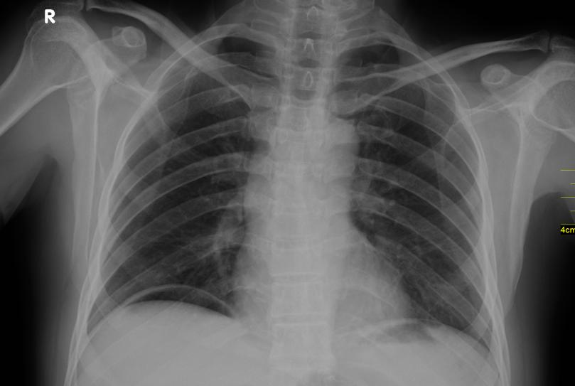
Now what?

-OR for exploratory laparotomy. Your patient is hemodynamically normal through the case, you suction some free fluid, looks like bowel prep. How would you repair the perforation?
-Primary repair
- V s resection with anastomosis +/- diversion

(Resident must be able to realize ability to offer primary anastomosis in hemodynamically stable patient, resident can divert their anastomosis / preferable over Hartman’s )

What if the site of the polypectomy/biopsy was highly suspicious for colo n cancer and now presents with peritonitis, fever, and tachycardia?

- OR
  - E x lap
  - Oncologic resection and anastomosis if able (high ligation of vessels). +/-diversion. (Depending on the location of the tumor, and the location of the perforation)

Scenario 2: Same patient presents 36 hours after hot snare polypectomy of 1cm lesion in the ascending colon with abdominal pain in the right hemiabdomen, focal guarding in the right mid abdomen, and mild leukocytosis of 13 000. CT demonstrates thickening of small segment of ascending colon, n o pneumoperitoneum or free fluid.
What is your Diagnosis ?
-Postpolypectomy syndrome.

How would you manage it?
  - NPO
  - IVF
  - IV antibiotics then PO abx.

Scenario 3:Same patient presenting 4 hours post colonoscopy after passing out at home while attempting to stand, and complaining of significant left sided abdominal pain that is now more diffuse.
He’s tachycardic to 115, BP 100/80, hemoglobin 9 from 14 pre-procedure. Exam reveals distention of the abdomen and diffuse guarding.
What is your differential diagnosis?
  - splenic lac eration.
  - Hemorrhage from polypectomy site.

CT demonstrates splenic laceration with active extravasation and hemoperitoneum. How would you manage?

- IVF
- T ype and cross
- Transfuse if becomes unstable.
- O R for exploratory laparotomy, splenectomy vs. IR embolization.

Pitfalls:
- Not knowing the differential diagnosis.
- Not knowing post polypectomy syndrome and management.
- Should be able to consider anastomosis if hemodynamically stable.
- Not knowing risk of splenic laceration after colonoscopy.

Reference:https://www.asge.org/docs/default-source/education/practice_guidelines/doc-56321364-c4d8-4742-8158-55b6bef2a568.pdf

